Warning – Emergency Call System Fault – CGEA1.3

Functional Description

The purpose of the Emergency Call System fault warning contained within this STSS is to inform the driver that the emergency call system has failed and the vehicle needs to be taken in for service.

eCall is a European Commission initiative which mandates (per regulation EU 2015/758) all vehicles be equipped with an in-vehicle system that calls 112 in the event of a serious road accident or by manual activation. Upon activation of an eCall, the in-vehicle system will connect to a public cellular network and initiate a call to 112. Upon connection to 112, the in-vehicle system will send a minimum set of data which is a data package that includes information about the vehicle and its location. Once the minimum set of data has been transmitted, communication is opened up between the in-vehicle occupants and the public safety answering point using the vehicle's audio system.

The Emergency Call System Fault warning function correlates the EmgcyCallFalt_B_Dsply signal from the Telematics Control Unit Module (TCU) and Operational_Mode to either activate or deactivate the warning message on the cluster display.

Interfaces

Interface Context Diagram (I/O Block Diagram)
Figure 1: Emergency Call System Fault Warning Context Diagram
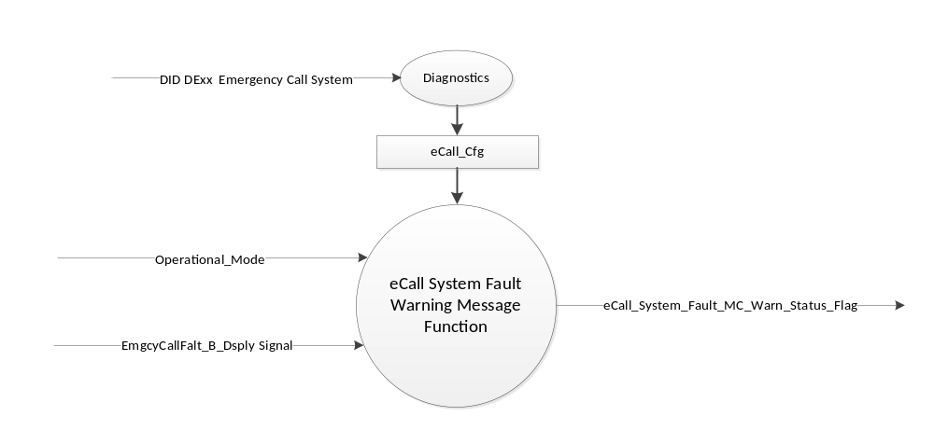

Inputs

      - INTERNAL:
            - eCall_Cfg
            - Operational_Mode

      - MUX signal on CAN
- EmgcyCallFalt_B_Dsply Signal
Signal Name | Size  (bits) | Detail | Units | State Encoded | Min. | Max.
EmgcyCallFalt_B_Dsply | 1 |  | SED |  | 0 (0x0) | 1 (0x1)
 |  | No |  | 0x0
 |  | Yes |  | 0x1

Outputs
      - eCall_System_Fault_MC_Warn_Status_Flag, which is used to control the state of the warning message.

Function/Performance

Operational Modes

Mode | Operational Mode
Sleep Mode | eCall System Fault Warning Inactive
Limited Mode | eCall System Fault Warning Inactive
Normal Mode | eCall System Fault Warning Active / Inactive
Crank Mode | eCall System Fault Warning Active / Inactive

Voltage Levels

Refer to the Cluster Features table located in the Operational Modes and Voltage Range Strategies section in this SPSS.

Human-Machine Interface

Visual

Indicator Graphics / Display Format

Message Center Text Warning Messages as defined in section Table 1.2 of this document.

Indicator Color Coordinates

Reference section COLOR & ILLUMINATION REQUIREMENTS (GRAPHICS).

Audio

None

Switch Control Logic

None.

System Accuracy

Within 100 msec of receiving a message that results in a change of state the cluster will update the output flag to the proper state.

Operation: Performance and Functional

Subsystem Algorithm Flowchart / State Diagram

Figure 2: Emergency Call System Diagnostic Routine Diagram
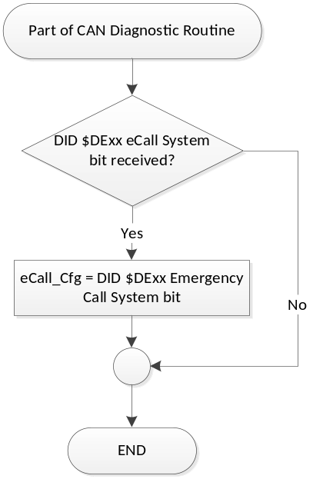

- State Matrix for eCall Systemshivoham
- Fault MC Status Flag
eCall_Cfg | Operational_  Mode | EmgcyCallFalt_B_Dsply Signal | eCall_System_Fault_  MC_Warn_Status_Flag
Enabled (0x1) | Normal or Crank | Yes (0x1) | Active
Enabled (0x1) | Normal | Declared Missing as per 1.4.1 | Active
All Other Cases |  |  | Inactive

- Pedestrian Sounder Flag MC Status Flag to MC Message IDs
MC Status Flag | Mc Warning Message ID
eCall_System_Fault_MC_Warn_Status_Flag | W3519

Operation Description (supports algorithm flowchart /state diagram)

- For definition of how the Message Center arbitrates and displays Active warnings, see the Warning / Alert Display Logic Diagram, located in the Message Center – X Display with W Button Interface section of this SPSS (where X and W are appropriate values in this document).

- The warning shall only be activated when eCall_Cfg is set to “Enabled” (0x1).

Function Safety Classification (EMC)

Class B

Memory Storage
Parameter Name | Description | Value at  Battery Connect | Value at  Module Wake-up
eCall_System_Fault_MC_Warn_Status_Flag | Output display status flag used to activate warning. | Inactive | Inactive
EmgcyCallFalt_B_Dsply Signal | CAN signal sent from the TCU module. | No (0x0) | No (0x0)
eCall_Cfg | State Indicator for feature presence controlled via CAN at EOL at VO plant. Defaulted to DISABLED at supplier manufacturing. | Use Stored Value | Use Stored Value
Operational_Mode | 4 state indicator for cluster operational mode. | Limited | Limited, Normal or Crank

Prove Out

None.

Reconfigurable Telltale

None

Message Center Message

See Section 1.3.5.1 for state tables and Table 1.2 for Warning Message ID.

Error Handling

Missing Message Strategy

The signals will be declared missing as per the Diagnostics section of this SPSS.

DTCs states and history will be determined as per the Diagnostics section of this SPSS.

If eCall_Cfg = 0x0 (Disabled), the cluster shall never log a missing message DTC due to this feature.

Diagnostics

Self Test

None.

Engineering Test Mode

None.

Part II Performance

DID $DExx
Block  Num | Block Description | Size (bits) | Byte(s) | Bit(s) | State: Description | "0" | "1" | Default | Comments/  Information
PACKETED BLOCKS
$xx | Option Content (B&A) | 1 | * | * | Emergency Call System | Disabled | Enabled | Disabled | To be enabled on EU variants only.
 | *Byte and bit location to be identified in Part II Specification for this cluster.

Supported Diagnostic Trouble Codes (DTCs)

DTCs shall be logged as per the diagnostics section of this SPSS.*

DTC | Description
C19800 | Lost Communication With Telematic Control Unit Module

Reference Specifications

IS-0001 WARNINGS/INDICATORS/DISPLAYS PROVEOUT
IS-0046 INSTRUMENTATION MATERIAL RESISTANCE TO CLEANING
IS-0052 OPERATING VOLTAGES - FUNCTIONAL/PERFORMANCE
IS-0069 FUNCTIONAL IMPORTANCE CLASS
IS-0324 WINDSHIELD & OTHER REFLECTIONS
IS-0327 WARNING INDICATOR EVALUATION
IS-0379 NORTH AMERICAN WARNINGS AND INDICATORS STRATEGY

IL-0021 CRAFTSMANSHIP - DISPLAYS
IL-0023 CLARITY/LEGIBILITY/READABILITY
IL-0025 INTERIOR ILLUMINATION INTENSITY
IL-0027 VISUAL CONTRAST
IL-0043 OPERATIONAL ENVIRONMENT FUNCTIONALITY
IL-0045 COLOR
IL-0048 ILLUMINATION ACCEPTABILITY

03-0661 PLACEMENT: CONTROL AND DISPLAY LOCATIONS
03-0662 PLACEMENT: LOGICAL GROUPING FUNCTION AND USAGE
03-0664 PLACEMENT: DOWN VISION TO COMPONENTS WITH HIGH VISUAL DEMAND
03-0665 PLACEMENT: EXPECTED LOCATIONS OF CONTROLS AND DISPLAYS VDS
03-0670 INTERIOR VISIBILITY
03-0671 INTERIOR VISIBILITY: REFLECTIONS FROM COMPONENTS & SURFACES
03-0672 INTERIOR VISIBILITY: REFLECTIONS IN DISPLAYS
03-0673 INTERIOR VISIBILITY: VISUAL OBSCURATIONS
03-0674 INTERIOR VISIBILITY: ILLUMINATION CONTROLS / DISPLAYS
03-0675 INTERIOR VISIBILITY: VEILING GLARE
03-0677 INTERIOR VISIBILITY: SUNLIGHT WASHOUT
03-0681 IDENTIFICATION: CHARACTER AND SYMBOL SIZE
03-0682 IDENTIFICATION: LEGIBILITY
03-0685 IDENTIFICATION: SYMBOLS, ABBREV FOR CONTROL
03-0721 LOGIC OF OPERATION: OPERATIONAL STEREOTYPES
03-0722 LOGIC OF OPERATION: INTERPRETATION
03-0723 LOGIC OF OPERATION: USE OF SYSTEMS WITH VISUAL DISPLAYS

Revision History

STSS Module Revision History

Revision Level | Name | Change Description | Date
1.0 | V. Patel | Initial release.  (Feature owner: Carl, James) | 12/10/2015

